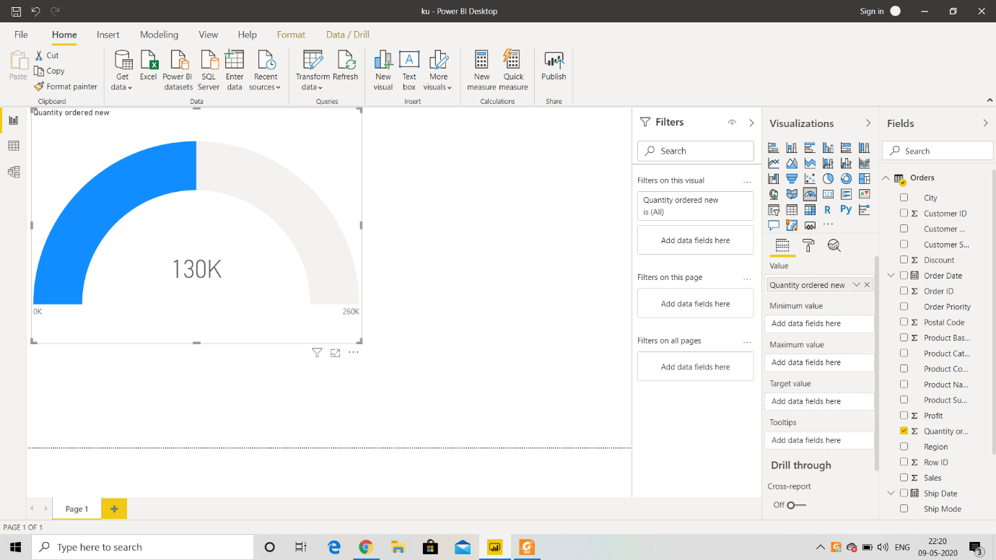

POWER BI INSTALLATION SCREEN SHOT

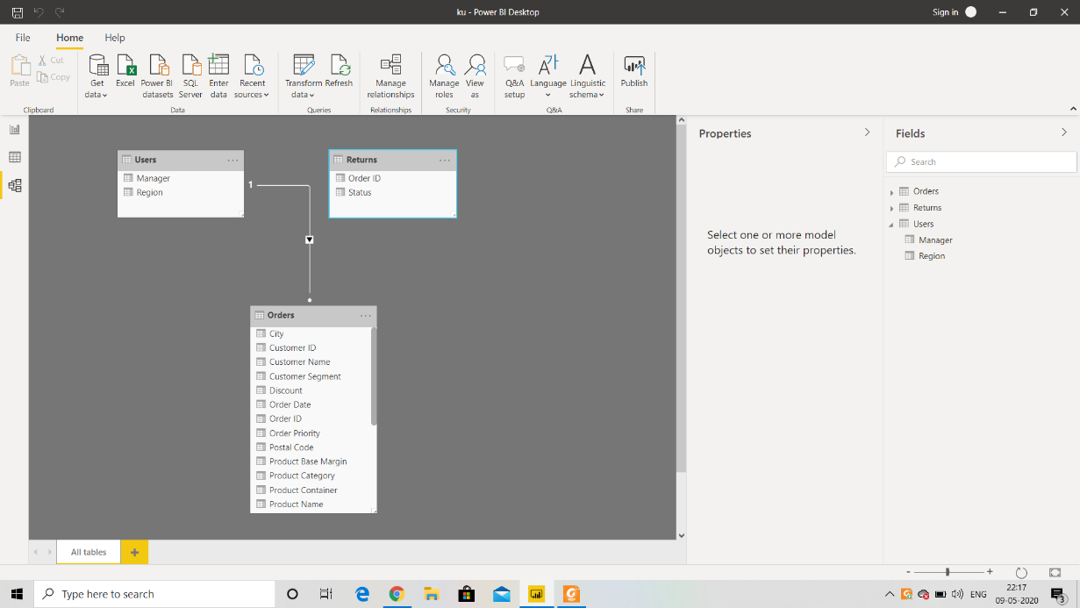

MODEL VIEW

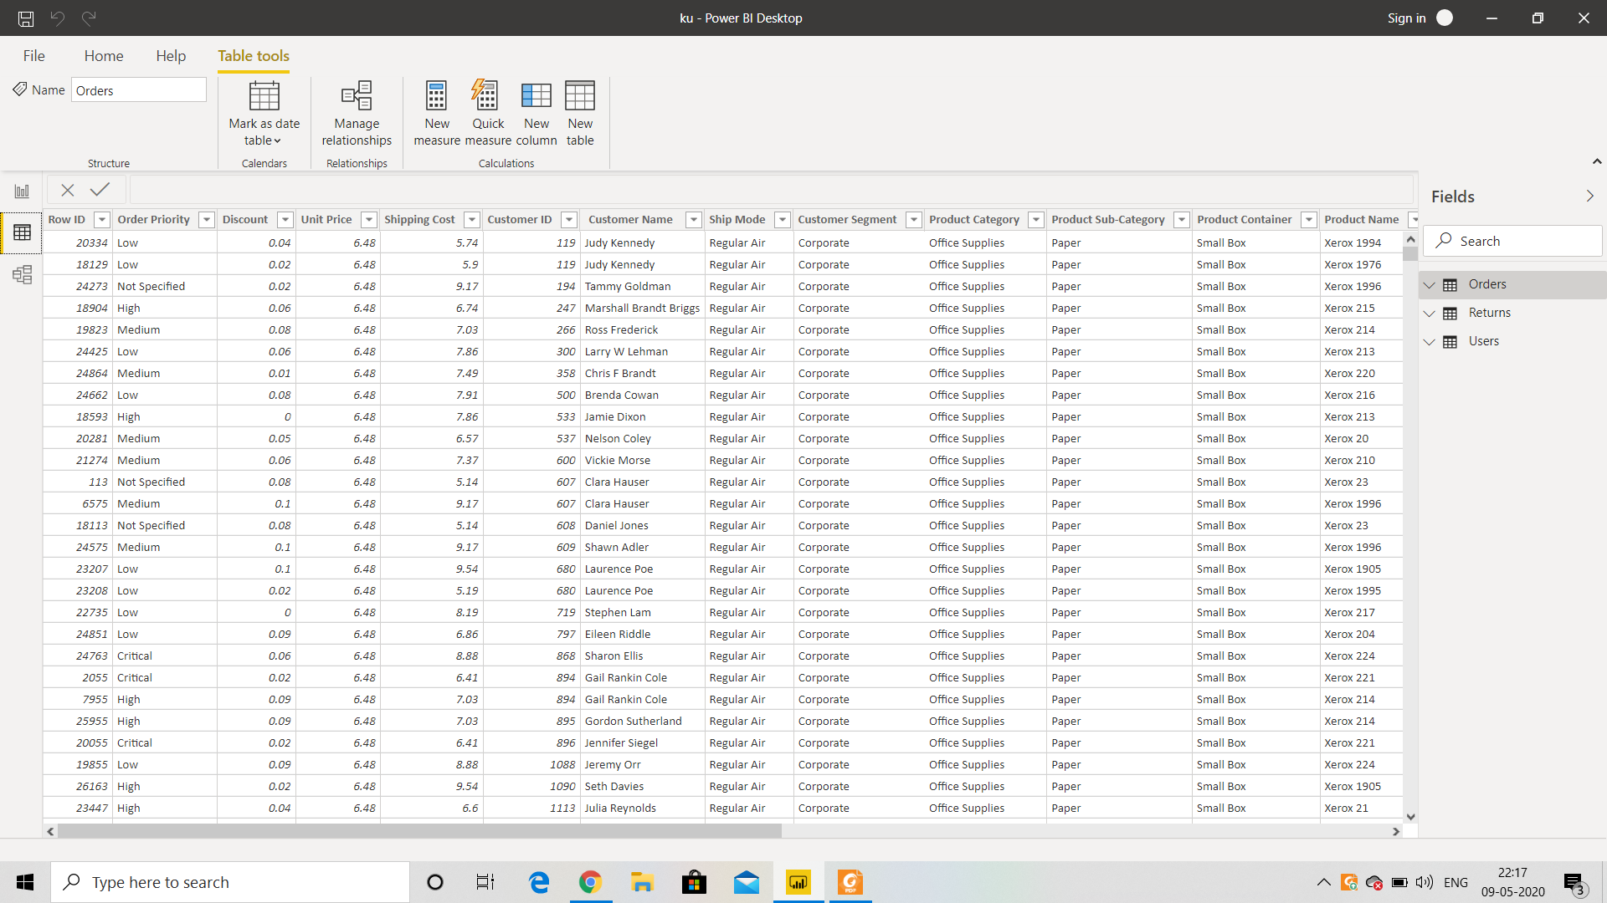

DATA VIEW



REPORT VIEW

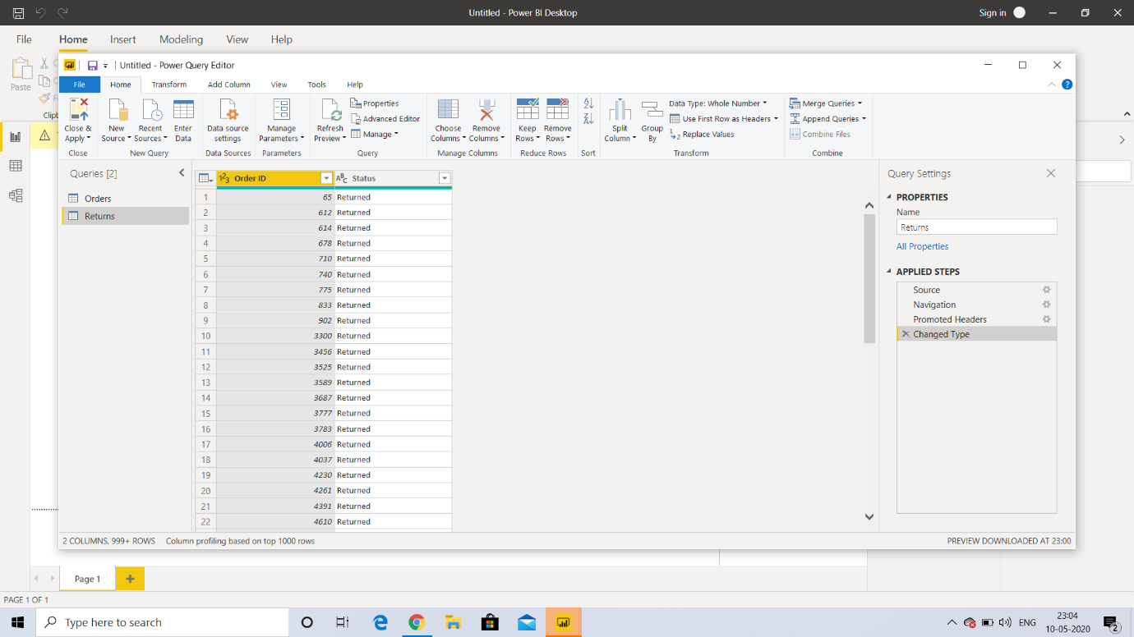

POWER QUERY EDITOR

Prepare a document with details of the following along with their price

|  |  |  |
| --- | --- | --- |
| **Power BI Desktop**  This offering is free to any single user and includes data cleaning and preparation, custom visualizations and the ability to publish to the Power BI service. | **Power BI Pro**  The Pro plan costs $9.99/user/month. It includes data collaboration, data governance, building dashboards with a 360-degree real-time view and the ability to publish reports anywhere. | **Power BI Premium**  The Premium plan starts at $4,995 a month per dedicated cloud compute and storage resource. |